Project Design Phase-II Technology Stack (Architecture & Stack)

|  |  |
| --- | --- |
| Date | 10 NOVEMBER 2022 |
| Team ID | PNT2022TMID36315 |
| Project Name | Project - Car Resale Value Prediction |
| Maximum Marks |  |

Technical Architecture:

The Deliverable shall include the architectural diagram as below and the information as per the table1 & table 2

Example: Order processing during pandemics for offline mode

Reference: [https://developer.ibm.com/patterns/ai-powered-backend-system-for-order-processing-during-](https://developer.ibm.com/patterns/ai-powered-backend-system-for-order-processing-during-pandemics/) [pandemics/](https://developer.ibm.com/patterns/ai-powered-backend-system-for-order-processing-during-pandemics/)

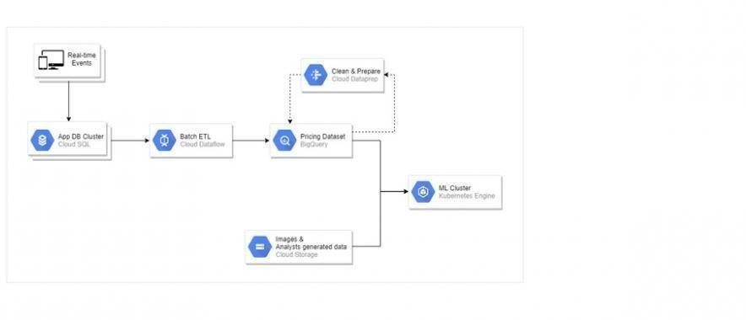

Table-1 : Components& Technologies:

|  |  |  |  |
| --- | --- | --- | --- |
| **S.N**  **o** | **Component** | **Description** | **Technology** |
| 1. | User Interface | How user interacts with application e.g.  Web UI, Mobile App, Chatbot etc. | HTML, CSS, JavaScript / Angular Js /  React Js etc. |
| 2. | Data preprocessing | Image of the particular vehicle uploaded through the websites and pre-processed using Machine learning  algorithm | Using the various model used to process the data |
| 3. | Value prediction | Machine learning model to predict the  Value of the vehicle uploaded in the website | Various models |
| 4. | Vehicle recommendation | After predicting the value , vehicle is suggested | Python |
| 5. | Database | Data’s are stored in database | MySQL, NoSQL, etc. |
| 6. | Cloud Database | The model is described in the application | IBM DB2, IBM Cloudant etc. |
| 7. | File Storage | Machine learning models are used for image pre-processing, value prediction and vehicle  recommendation | Data pre-processing model  ,value prediction model |
|  | External API-1 | Its used for the data pre-processing | IBM server , Google drive |
| 8. | External API-2 | For the users knowing value of the vehicle | Application |
| 9. | Machine Learning Model | Machine Learning Model for processing the data and  predicting the value | Object Recognition Model, etc. |

Table-2: Application Characteristics:

|  |  |  |  |
| --- | --- | --- | --- |
| **S.N**  **o** | **Characteristics** | **Description** | **Technology** |
| 1. | Open-Source Frameworks | Google colaboratory , Anaconda Navigator, Jupyter  Network,python flask | Data storage in google drive |

|  |  |  |  |
| --- | --- | --- | --- |
| 2. | Security Implementations | The scalability architecture is 2-tier .The client is the user  and server is the IBM cloud server | SHA-256, Encryptions, IAM Controls,  OWASP etc. |
| 3. | Scalable Architecture | It must support higher workloads without any issues | Models , IBM cloud |
| 4. | Availability | Availability of applications for use of load balancers,  distributed servers | IBM cloud |
| 5. | Performance | Performance of the application should be high | IBM cloud |

References:

<https://c4model.com/>

[https://developer.ibm.com/patterns/online-order-processing-system-during-](https://developer.ibm.com/patterns/online-order-processing-system-during-pandemic/) [pandemic/](https://developer.ibm.com/patterns/online-order-processing-system-during-pandemic/) <https://www.ibm.com/cloud/architecture> <https://aws.amazon.com/architecture>

<https://medium.com/the-internal-startup/how-to-draw-useful-technical-architecture-diagrams-2d20c9fda90d>